Fix DBT_VirtualIndex
Thursday, December 7, 2023
2:49 PM

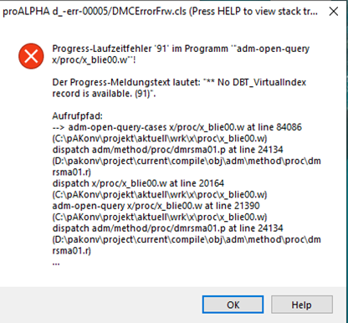
Add PA Virtual at query-string and open-query
~{&PA-VIRTUAL-INDEX-PHRASE}

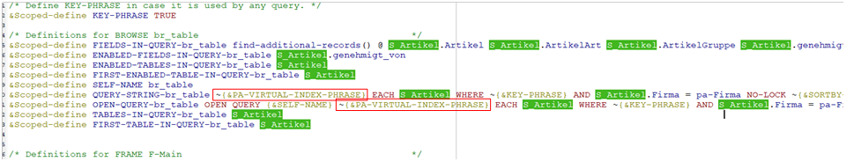

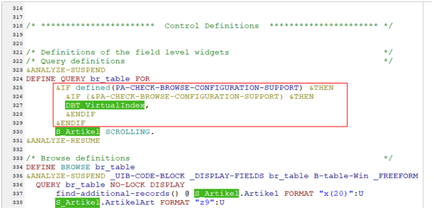
add this code in block Define query br_table
&IF defined(PA-CHECK-BROWSE-CONFIGURATION-SUPPORT) &THEN
&IF {&PA-CHECK-BROWSE-CONFIGURATION-SUPPORT} &THEN
DBT_VirtualIndex,
&ENDIF
&ENDIF

